Given the roots of two binary trees p and q, write a function to check if they are the same or not.

Two binary trees are considered the same if they are structurally identical, and the nodes have the same value.

**Example 1:**

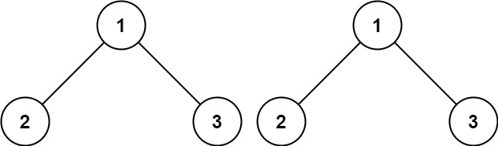

**Input:** p = [1,2,3], q = [1,2,3]

**Output:** true

**Example 2:**

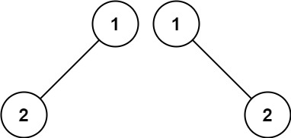

**Input:** p = [1,2], q = [1,null,2]

**Output:** false

class Solution {

public boolean isSameTree(TreeNode p, TreeNode q) {

if(p==null && q==null)

{

return true;

}

if(p!=null && q!=null)

{

return (p.val==q.val && isSameTree(p.left,q.left) && isSameTree(p.right,q.right)) ;

}

return false;

}

}